15.Write a Pandas program to keep the rows with at least 2 NaN values in a given DataFrame
Aim
To write a Pandas program to display only those rows in a DataFrame that contain at least two missing (NaN) values.
Algorithm
- Import the Pandas and NumPy libraries.
- Create a DataFrame containing some missing (NaN) values.
- Use the isna() function to identify missing values.
- Count the number of NaN values in each row using sum(axis=1).
- Select the rows where the count of NaN values is greater than or equal to 2.
- Display the filtered DataFrame.
PROGRAM:
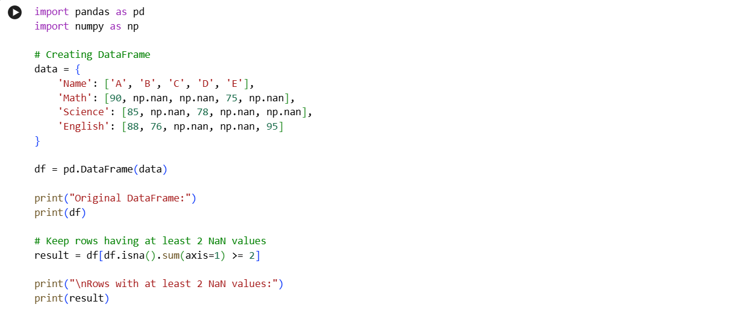
OUTPUT: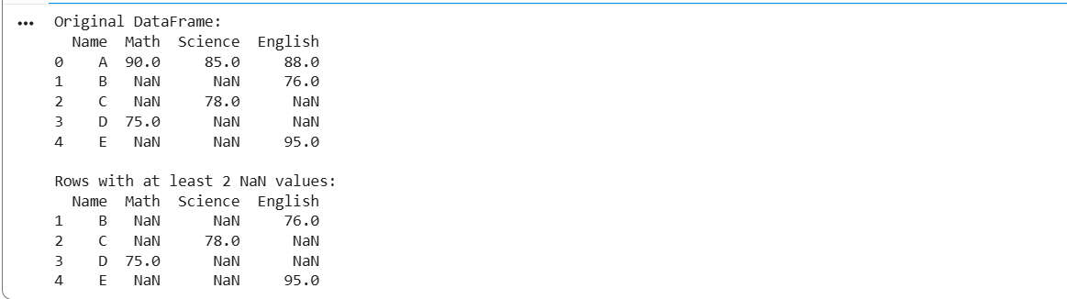
16. Write a Pandas program to split the following DataFrame into groups based on school code. Also check the type of GroupBy object.
Aim
To write a Pandas program to group the records of a DataFrame based on the School Code and determine the type of the resulting GroupBy object.
Algorithm
- Import the Pandas library.
- Create a DataFrame containing student details and school codes.
- Use the groupby() function to group the records based on the School_Code column.
4.Display the type of the GroupBy object using the type() function.
PROGRAM:
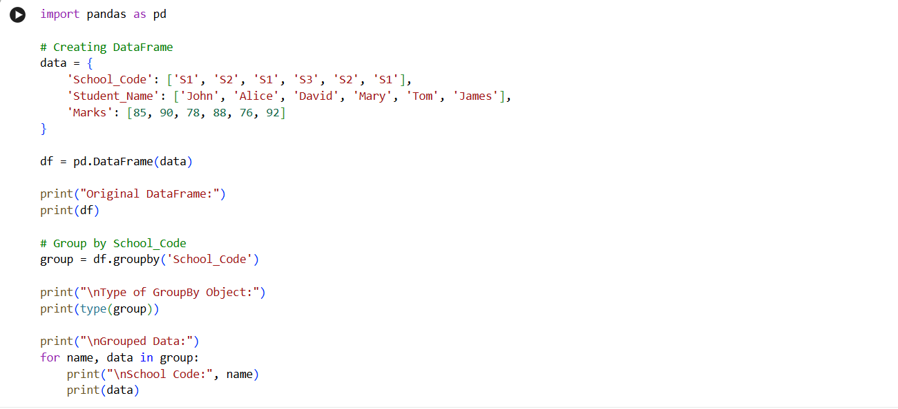
OUTPUT:
